**Tribhuvan University**

**Institute of Science and Technology**



**Central Department of Computer Science and Information Technology**

**Kirtipur, Kathmandu**

**First Assignment**

**on**

**“ Test case strategy for reduction of test paths such that test time and cost is reduced with minimal impact with respect to disaster. ”**

**Submitted By**

Suryodaya Aidi

Roll No. 39/079

Section : ‘B’

**Submitted To**

Mr. Sarbin Sayami

Head of Department,

Central Department of Computer Science and Information Technology

April, 2023

Question : Develop a test case strategy for reduction of test paths (sampling) such that test time and cost is reduced with minimal impact with respect to disaster. (White box testing)

1.‌ Algorithm

2. ‌Graph/Flowchart

3. ‌Cyclomatic complexity

4. ‌Test Paths

**1. Algorithm**

I am thinking about the ranking of a sports team or member in a particular event or tournament based on the how they are accepting official decision or challenge the decision having review system. Teams getting successful review gets positive points and team with unsuccessful review gets negative points. Obviously the negative points is the certain percentage of positive review. For example if a team gets successful review the total points will increase by 20 and if the team gets negative review their points will decrease by 8 or 10. Throughout the tournament teams with higher points are said to be the good teams. This strategy can help to reduce the unnecessary time spent by the teams during the live matches. Their will be risk to challenge the official decision so teams should careful about the review taking process.

Algorithm

1. Start.(Any match of the tournament.)
2. Input points(P) and review(R) of the team.
3. System reads the value of P and R.
4. Several decision are made in the game and if a team thinks that they are getting unfair decision by the official they can challenge the decision up to R unsuccessful times.
5. If now review is taken go to step 8.
6. Display reviewed decision.
7. If review taken is successful

P = P + 20

R = R

If review is unsuccessful

P = P – 10

R = R

1. Display points of the team and review remaining for the team.
2. To challenge next decision team must have at least one review remaining. So, if team have left review and wants to review then go to step 4.
3. End.(Game Over)

**2. Flowchart**

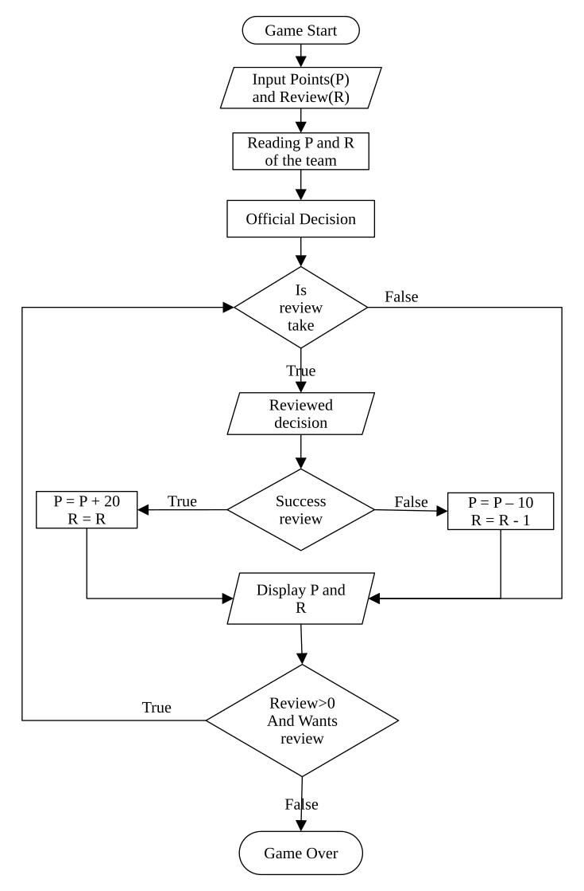Figure 1: Flowchart for Team Ranking Algorithm Based on Decision Challenged

**Graph**

**3. Cyclomatic Complexity**

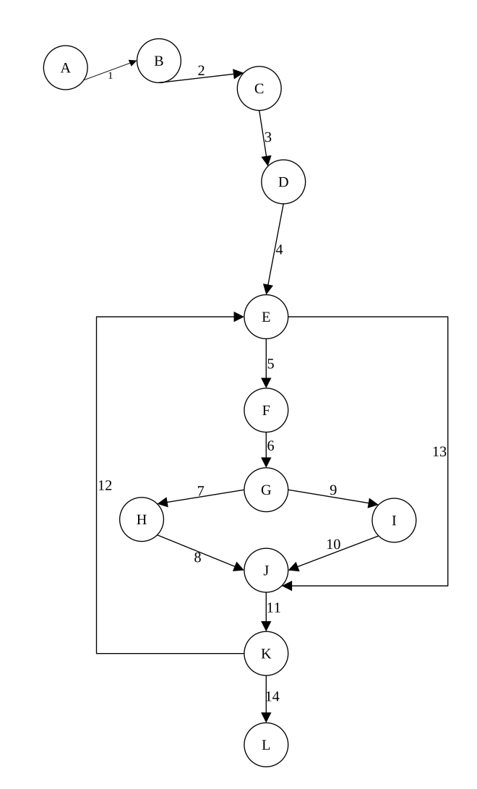Figure 2: Graph for the Team Ranking Algorithm Based On Decision Challended

Analyzing the above graph here are total edges(E) = 14 and, the total vertices or nodes(V) = 12. So, the cyclomatic complexity is as following.

Cyclomatic Complexity = Edges(E) – Vertices(V) + 2 = 14 – 12 + 2 = 4.

**4. ‌Test Paths**

Here we are testing the paths of the above mentioned algorithm and graph using the technique called Statement Coverage and Branch Coverage.

Statement Coverage = $\frac{VisitedNodesofthePaths}{TotalNodes}$ X 100%,

Branch Coverage = $\frac{VisitedPredicatedNodes}{TotalPredicatedNodes}$ X 100%

Here we have total three predicate nodes and they are node E, G, and K.

Table 1: Path Table

|  |  |  |  |
| --- | --- | --- | --- |
| **Path No.** | **Path** | **Statement Coverage** | **Branch Coverage** |
| 1 | A->B->C->D->E->J->K->L | 8/12 = 66.67% | 2/3 = 66.67% |
| 2 | A->B->C->D->E->J->K->E->J->K->L | 11/12 = 91.67% | 3/3 = 100% |
| 3 | A->B->C->D->E->J->K->E->F->G->H->J->K->L | 14/12 = 116.67% | 5/3 = 166.67% |
| 4 | A->B->C->D->E->J->K->E->F->G->I->J->K->L | 14/12 = 116.67% | 5/3 = 166.67% |
| 5 | A->B->C->D->E->F->G->H->J->K->L | 11/12 = 91.67% | 3/3 = 100% |
| 6 | A->B->C->D->E->F->G->H->J->K->E->F->G->H->J->K->L | **17/12 = 141.67%** | **6/3 = 200%** |
| 7 | A->B->C->D->E->F->G->H->J->K->E->F->G->I->J->K->L | **17/12 = 141.67%** | **6/3 = 200%** |
| 8 | A->B->C->D->E->F->G->H->J->K->E->J->K->L | 14/12 =116.67% | 5/3 = 166.67% |
| 9 | A->B->C->D->E->F->G->I->J->K->L | 11/12 = 91.67% | 3/3 = 100% |
| 10 | A->B->C->D->E->F->G->I->J->K->E->F->G->I->J->K->L | **17/12 = 141.67%** | **6/3 = 200%** |
| 11 | A->B->C->D->E->F->G->H->I->K->E->F->G->H->J->K->L | **17/12 = 141.67%** | **6/3 = 200%** |
| 12 | A->B->C->D->E->F->G->H->I->K->E->J->K->L | 14/12 = 116.67% | 5/3 = 166.67% |

**Conclusion**

Hence, As shown in above table the statement and path coverage for following paths are the highest so that they are the best paths for the algorithams.

Table 2: Best Paths of The Path Table

|  |  |  |  |
| --- | --- | --- | --- |
| **Path No.** | **Path** | **Statement Coverage** | **Branch Coverage** |
| 6 | A->B->C->D->E->F->G->H->J->K->E->F->G->H->J->K->L | **17/12 = 141.67%** | **6/3 = 200%** |
| 7 | A->B->C->D->E->F->G->H->J->K->E->F->G->I->J->K->L | **17/12 = 141.67%** | **6/3 = 200%** |
| 10 | A->B->C->D->E->F->G->I->J->K->E->F->G->I->J->K->L | **17/12 = 141.67%** | **6/3 = 200%** |
| 11 | A->B->C->D->E->F->G->H->I->K->E->F->G->H->J->K->L | **17/12 = 141.67%** | **6/3 = 200%** |